

***CSS Essentials***

**Assignments**

|  |  |
| --- | --- |
| Document Code | 25e-BM/HR/HDCV/FSOFT |
| Version | 1.1 |
| Effective Date | 20/11/2012 |

**Hanoi, 04/2019**

RECORD OF CHANGES

|  |  |  |  |  |  |
| --- | --- | --- | --- | --- | --- |
| No | Effective Date | Change Description | Reason | Reviewer | Approver |
|  | 25/Jun/2018 | Create a new Lab | Create new | DieuNT1 | VinhNV |
|  | 01/May/2019 | Update Fsoft Template | Update | DieuNT1 | VinhNV |
|  |  |  |  |  |  |
|  |  |  |  |  |  |
|  |  |  |  |  |  |
|  |  |  |  |  |  |
|  |  |  |  |  |  |
|  |  |  |  |  |  |
|  |  |  |  |  |  |
|  |  |  |  |  |  |

Contents

Unit 1 – CSS Overview 4

Objectives: 4

Project Structure 4

Problem 1: 4

|  |  |
| --- | --- |
|  | **CODE: CSS-E.M.A101**  **TYPE: Medium**  **LOC: N/A**  **DURATION: 60 MINUTES** |

# Unit 1 – CSS Overview

Objectives:

* Understand overview of CSS
* Able to format simple text using CSS

Project Structure

* A project called **CSS-E.M.A101** (this will be your root folder) is provided to you
* Put your work for each problem in corresponding folder inside root folder

Problem 1:

Use CSS to change how this biography looks by changing the values of the properties.

1. Make the level one heading pink, using the CSS color keyword hotpink.
2. Give the heading a 10px dotted border-bottom which uses the CSS color keyword purple.
3. Make the level 2 heading italic.
4. Give the ul used for the contact details a background-color of #eeeeee, and a 5px solid purple border. Use some padding to push the content away from the border.
5. Make the links green on hover.

Expected output:

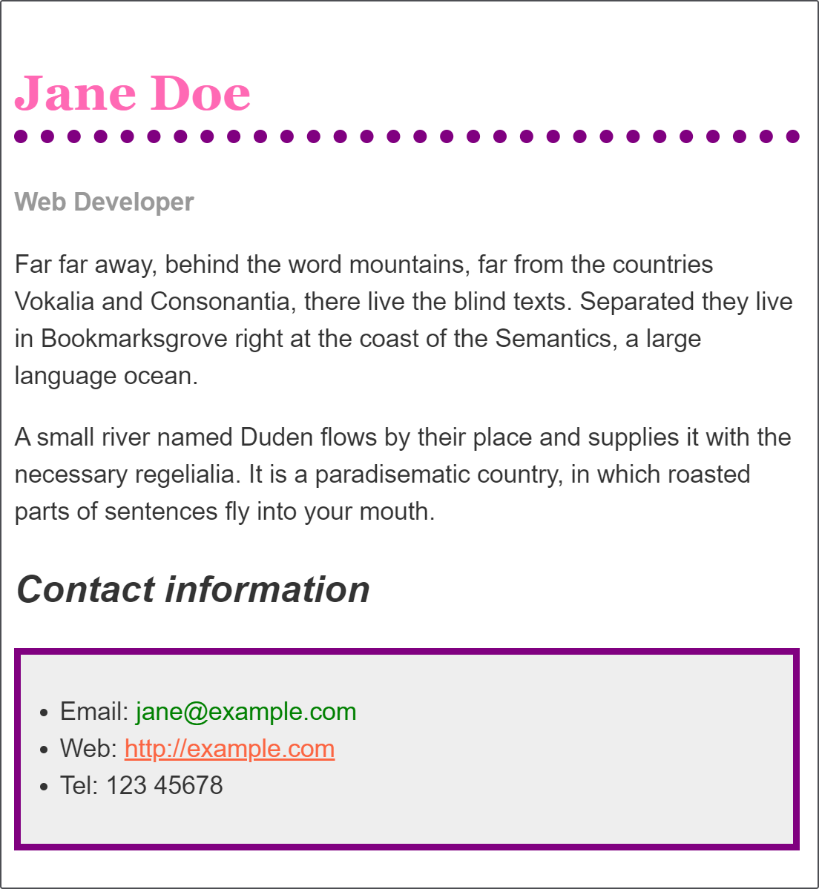

**-- THE END --**